|  |  |
| --- | --- |
| Image result for l&rcaa archery logo | **L&RCAA FOX AWARD**  **CLAIM FORM** |

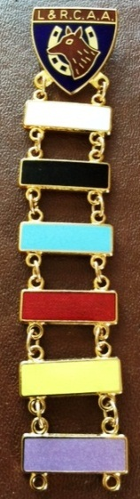Please complete the claim form below **and enclose a copy of the score sheet and/or results sheet (as applicable)**.

Claim forms, together with proof of payment of the appropriate fee of £2.00 per bar, should be returned to:-

Carol Smith

L&RCAA County Records Officer

12 Ivydale Road

Thurmaston

Leicester LE4 8NE

**Payment to be made by BACS before bars will be issued, LRCAA account details below:**

**Sort Code: 204917 Account Number: 93146421**

**Please note cheques will no longer be accepted**

|  |  |  |  |
| --- | --- | --- | --- |
| **Title:** | Mr / Mrs / Ms / Miss / Mstr | **Tel No:** |  |
| **Full Name:** |  | | |
| **Address:** |  | | |
|  | | |
|  | **Postcode:** |  |
| **Email Address:** |  | | |
| **AGB Number:** |  | | |
| **Age Group:** | Senior / Junior | **DOB (Junior):** |  |
| **Bowstyle:** | Compound / Recurve / Longbow / Barebow | | |
| **Club:** |  | | |

|  |  |  |  |  |  |  |
| --- | --- | --- | --- | --- | --- | --- |
| **Bar/s being Claimed (please tick✓)** | **White** | **Black** | **Blue** | **Red** | **Gold** | **Purple** |
|  |  |  |  |  |  |

Reminder - Bars **must** be claimed in date and colour order, with only one bar being issued per score shot

|  |  |  |  |
| --- | --- | --- | --- |
| **Date Shot** | **Type of Shoot**  (ie Club Target Day / Open Shoot / Tournament) | **Round** | **Score** |
|  |  |  |  |
|  |  |  |  |
|  |  |  |  |
|  |  |  |  |