The Foxes
Worcester
Sunday 11th December 2022
This event may be shot as an individual competition and/or as Stage 2 of the 2022 - 2023 Countesthorpe Triple. The Countesthorpe Triple will be shot over three rounds – The Foxes Portsmouth, The Foxes Worcester and LAOFAC WA18m. A separate entry form is required for each event and also for the Countesthorpe Triple. Competitors are responsible for making sure that they enter each of the separate stages. Entries for the Countesthorpe Triple must be received by The Foxes on or before 13th November 2022.

Address | Winstanley Community College  Kingsway North  Braunstone  Leicester  LE3 3BD
Judges | Mr T Tricker (COJ), Mr M Thomason, Ms M Inglis and Ms L Calvert
Lord/Lady Paramount | TBA
Assembly | Session A: 9am  Session B: 12pm  Session C: 3pm  Please arrive with time for equipment set up and inspection prior to assembly.
Photography | If you wish to take photographs during the tournament, please register on arrival. If you do not want to be included in any photographs or videos, please let the registration desk know when you arrive.
Awards | Awards will be presented for Lady and Gentlemen archers in four categories (Recurve, Compound, Barebow, Longbow) depending on the number of entrants and at the discretion of The Foxes Archery Club. Other bow styles will be included in one of those four categories for the purpose of awards, but will be a separate category in the results. Handicap Adjusted Awards will be given to the highest placed archers across the combined categories who have not been given a place award in any of the four categories above (and who have notified the organiser of their current handicap before they start shooting).
Entry Fees | Seniors £11  Juniors £6.50
Entry Forms  Account Name  Account No.  Sort Code | Entry by email and BACS payment is preferred.  The Foxes Archery Club  62173049  60-14-10  (Please note these details have changed since our last tournament.)  Alternatively, please complete a paper entry form and post a cheque (made payable to The Foxes Archery Club) to:  Tournament Organiser, The Foxes Archery Club  83 Parklands Drive  Loughborough  Leicestershire  LE11 2SZ  tournaments.thefoxes@gmail.com  Entries will be confirmed once payment is received.
Closing Date | Saturday 3rd December 2022, no refunds will be given after the closing date.
Area Map | Please note that the only access to Kingsway North is via Braunstone Lane  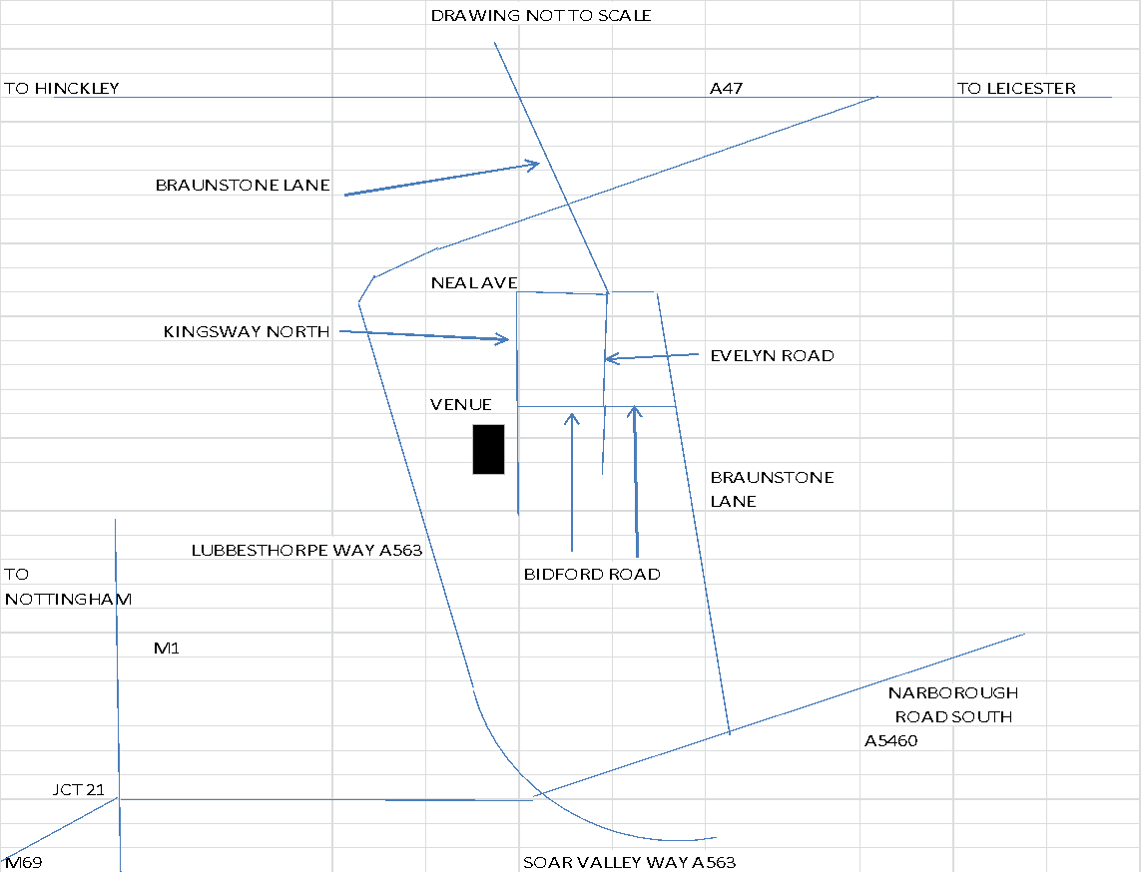
Notes
- All competitors must be affiliated to Archery GB or a World Archery member organisation and must show their 2022/23 membership card or e-card on arrival. If you do not have a current card, you must provide proof that you have paid your affiliation fee to the Club you are representing at the event.
- Shooting will be in accordance with Archery GB Rules of Shooting and all archers must comply with Archery GB rule 307 (dress regulations).
- Shooting will be in timed ends of five arrows in four minutes. Sighters will be one end of five arrows.
- Compound archers will shoot on five-spot faces with one archer shooting at each face. All other bow types will shoot on single spot faces, also with one archer shooting at each face.
- All archers will shoot on straw bosses. There will be up to four archers per boss, shooting in two details.
- Equipment inspection will take place before sighters for each round.
- Double entries will be accepted, only the first round shot will count for awards and for the Countesthorpe Triple. Archers who are given a place award in a category will not be considered for a Handicap Adjusted Award.
- The Foxes will not accept liability for any damage to or loss of archery equipment, cars or personal possessions on the site nor for self injury to any person(s) incurred during this tournament.
- Under the provisions of the AGB Protection of Children and Vulnerable Adults Policy, those who wish to take photographs at this event must register with the organisers on arrival. Whilst every effort will be made to ensure that unauthorised photography does not take place, The Foxes, the organisers and working party cannot be held responsible for breaches of this code. We therefore request that you report any unauthorised photography directly to the organisers.
- Winstanley Community College is a no-smoking area and smoking (including e-cigarettes and vaping) is prohibited in all areas of the campus.
- Record Status tournaments are liable for drug testing, competitors approached to give samples must comply. Refusal will be treated as a positive result. Archers under 18, a parent or guardian signing the entry signifies their consent to their child being drug tested if approached.
- Data Protection – When you enter this competition, you are agreeing that information will be collected and might be shared with tournament organisers, scoring systems, other competitors and may be published on web sites. For example target lists and results may be published containing some of the following information: First Name, Surname, Gender, Bow Style, Date of Birth/Age category, Email, Home Address, contact Phone Number, Club, AGB membership number, County, Region, Round (unless defined by age), Disabled (Y/N), Disability info. Contact information may be used by The Foxes to send you information about future events organised by the club.

WORCESTER SUNDAY 11TH DECEMBER 2022
Full name | Club | AGB No. | Bow style | H/C | Special requirements* | L/R handed | Jnr DoB | Session | Fee
Total Fee

Contact details
Name:
Address:
Phone: Email:
Signature of parent for each Junior entry:

* If you have any special requirements, please state them in the Special Requirements part of the form.
* If you shoot from a wheelchair or stool and need to stay on the line, please let us know.
*A provisional target list will be sent to competitors providing a legible email address, and will also be available on The Foxes website no less than 3 days before the event.
*By entering this competition I agree that the information I have provided might be shared as stated.

